Contents

.NET Interview Roadmap 2

OOPS 4

C# 5

.Net Framework 6

SQL Server 7

ASP.NET MVC 8

Asp.net Webforms 9

. ADO.NET/EF 10

.Net Core 11

WebApi 12

.Net Advance 13

## .NET Interview Roadmap

1. [.NET Complete Roadmap from Beginner to Expert | .NET Interview Roadmap | 2025 - YouTube](https://www.youtube.com/watch?v=VVjADzMSP3w)
2. [DotNet Interview Bootcamp - Interview Happy](https://www.interviewhappy.com/page/dotnetbootcamp)
3. [(1) C# .NET Interview Questions for 10 Years Experience - YouTube](https://www.youtube.com/playlist?list=PLQMqUlV2_B8ngL_PaT9UFsd0-PvnrpZGC)
4. [.NET Blog](https://devblogs.microsoft.com/dotnet/)

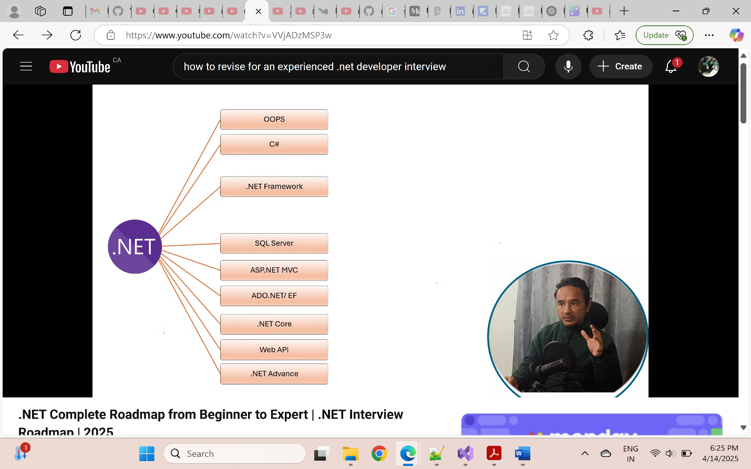

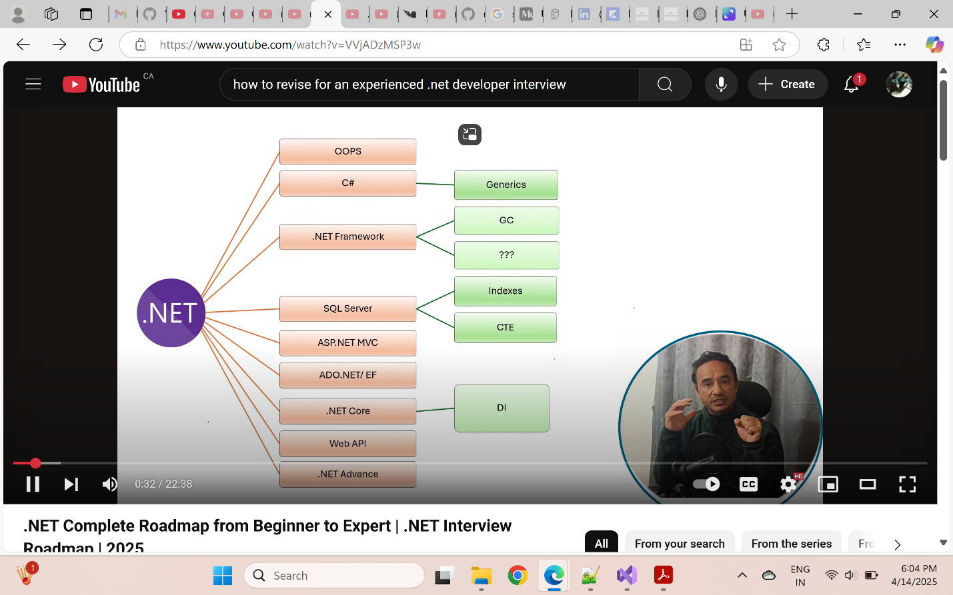

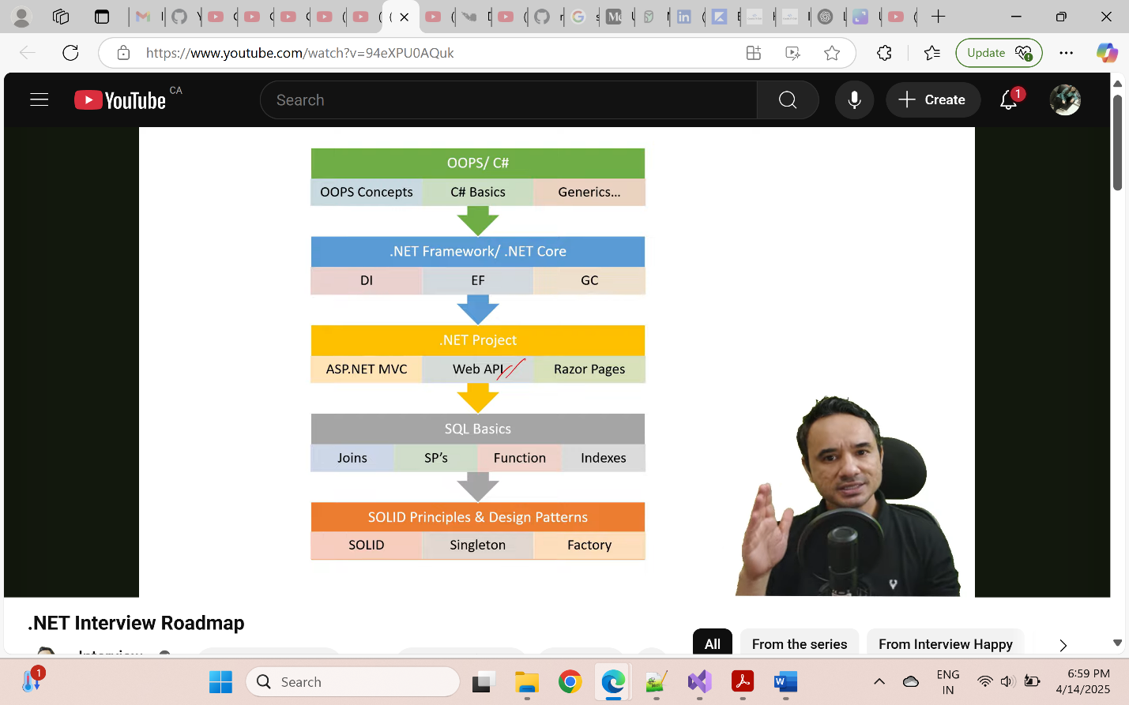

## OOPS

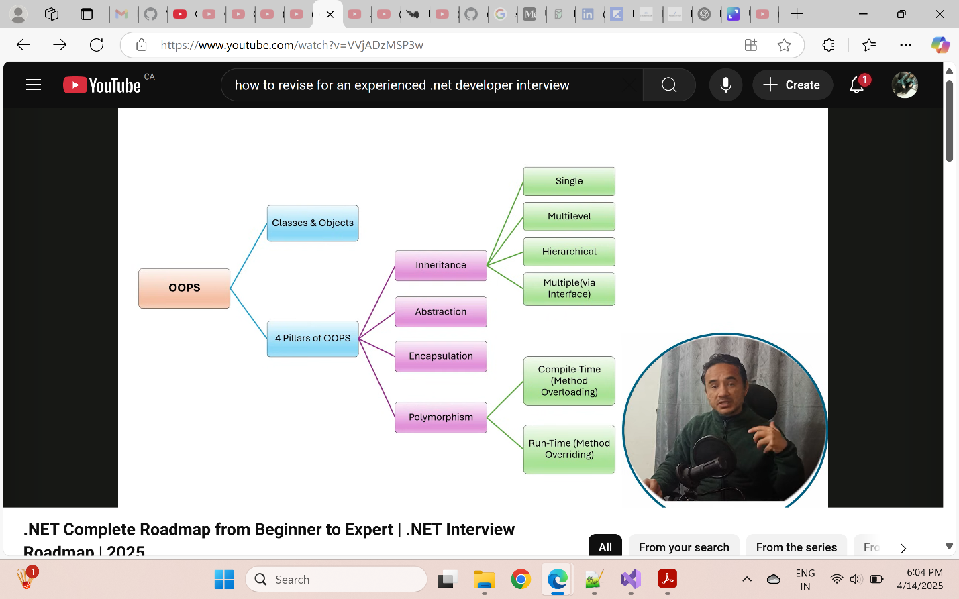

## C#

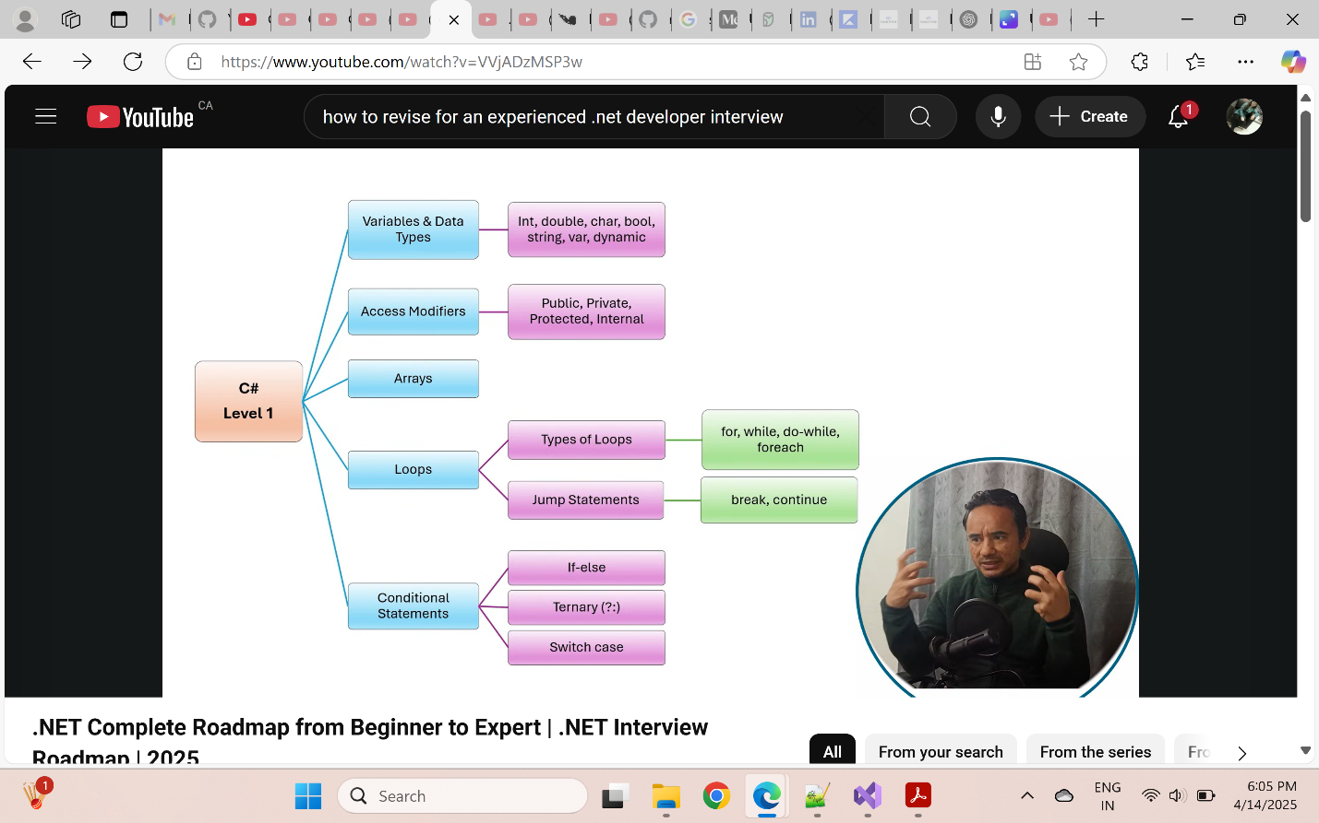

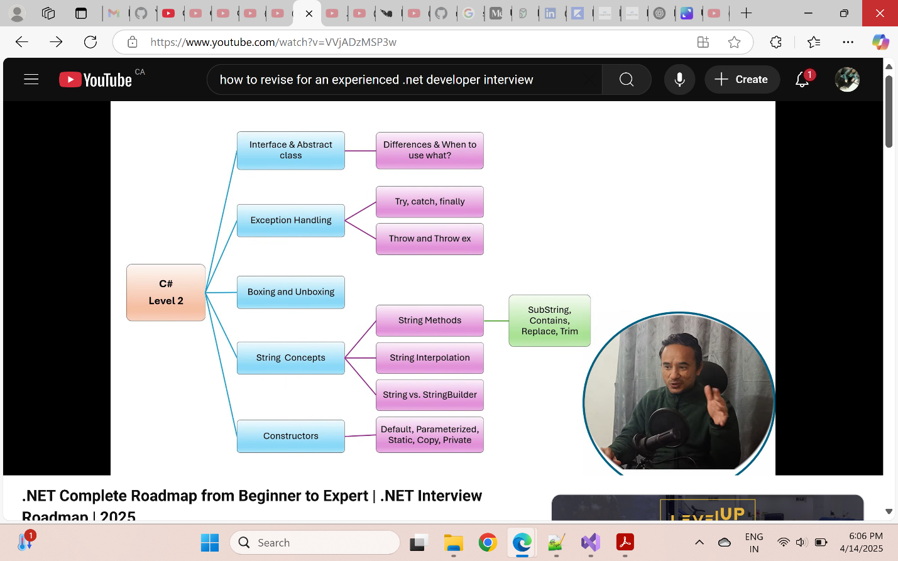

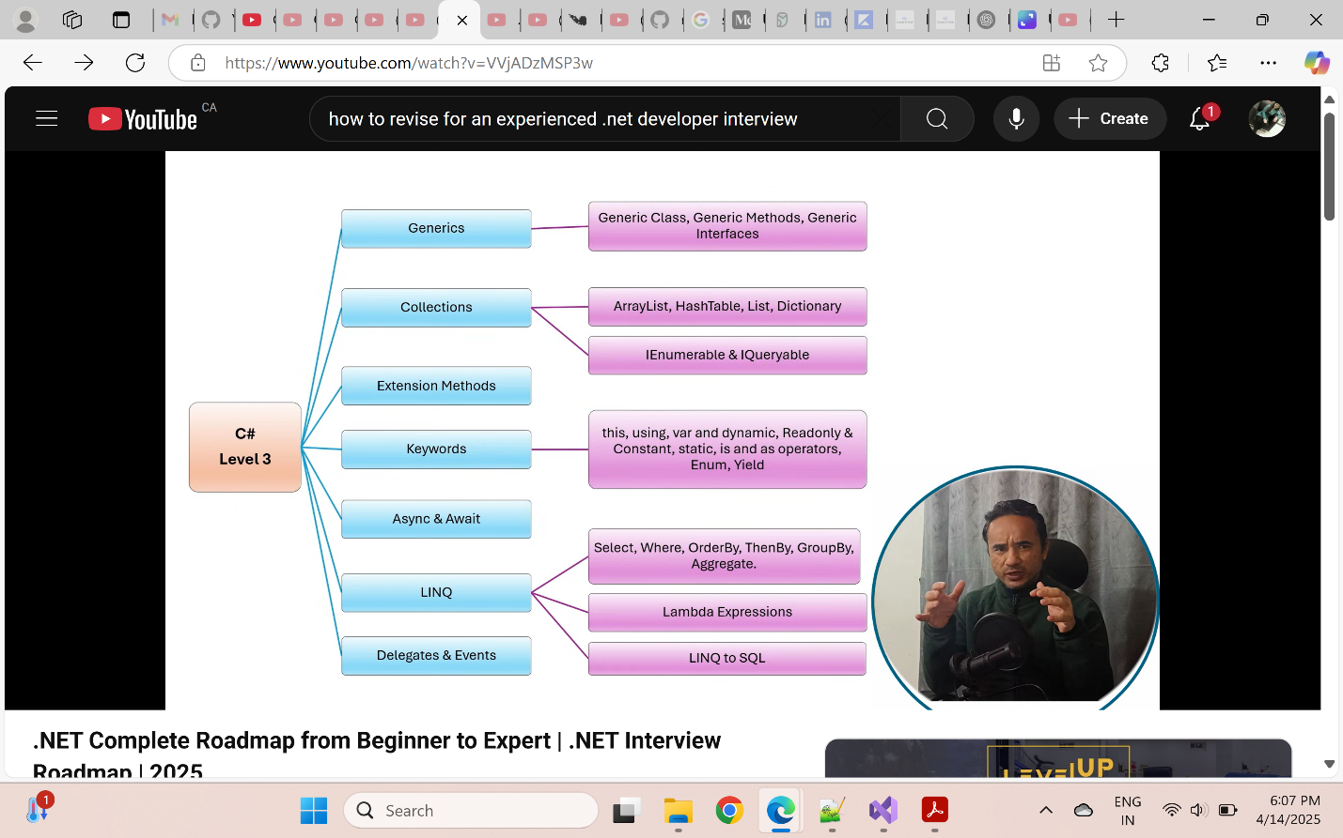

## .Net Framework

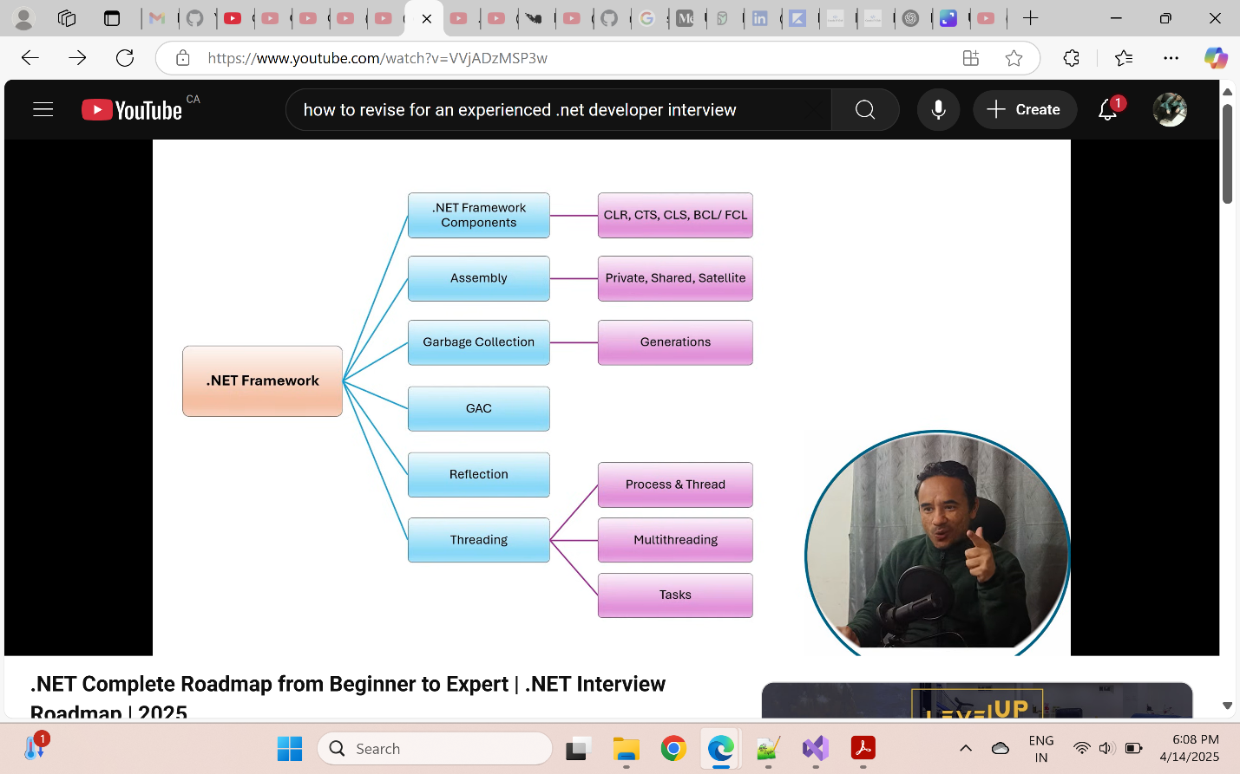

## SQL Server

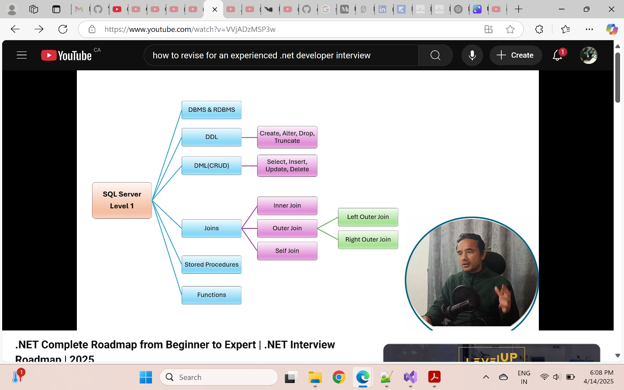

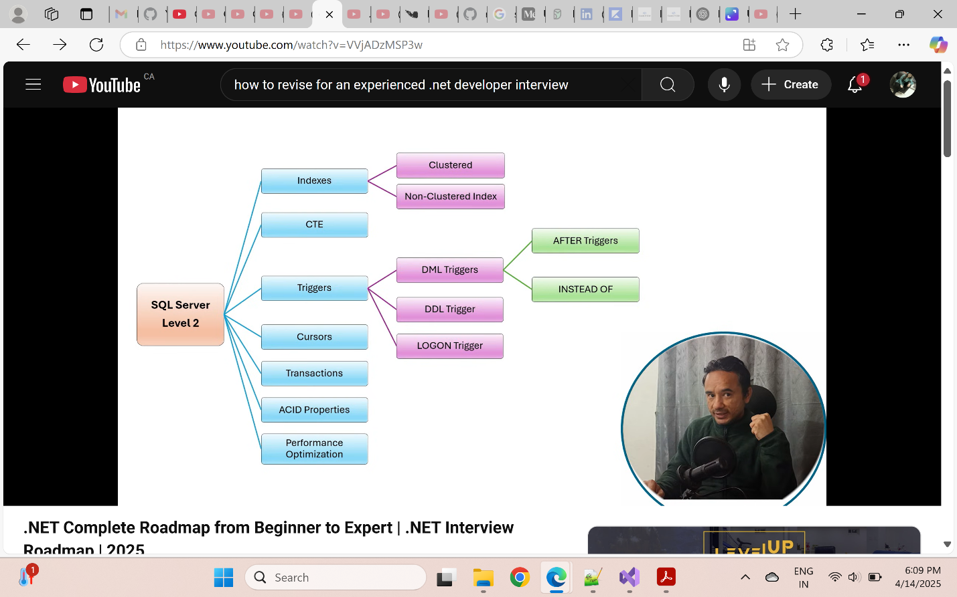

## ASP.NET MVC

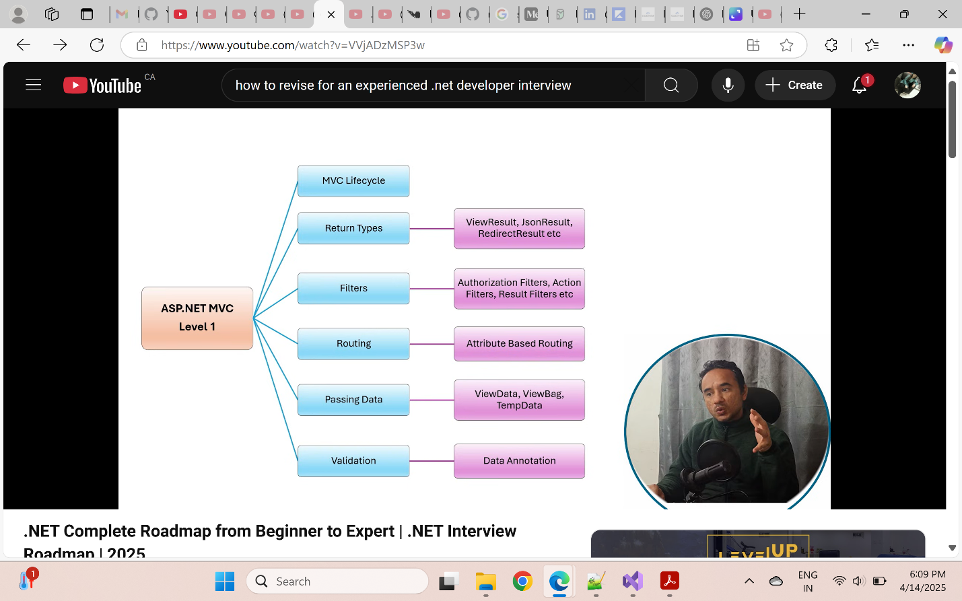

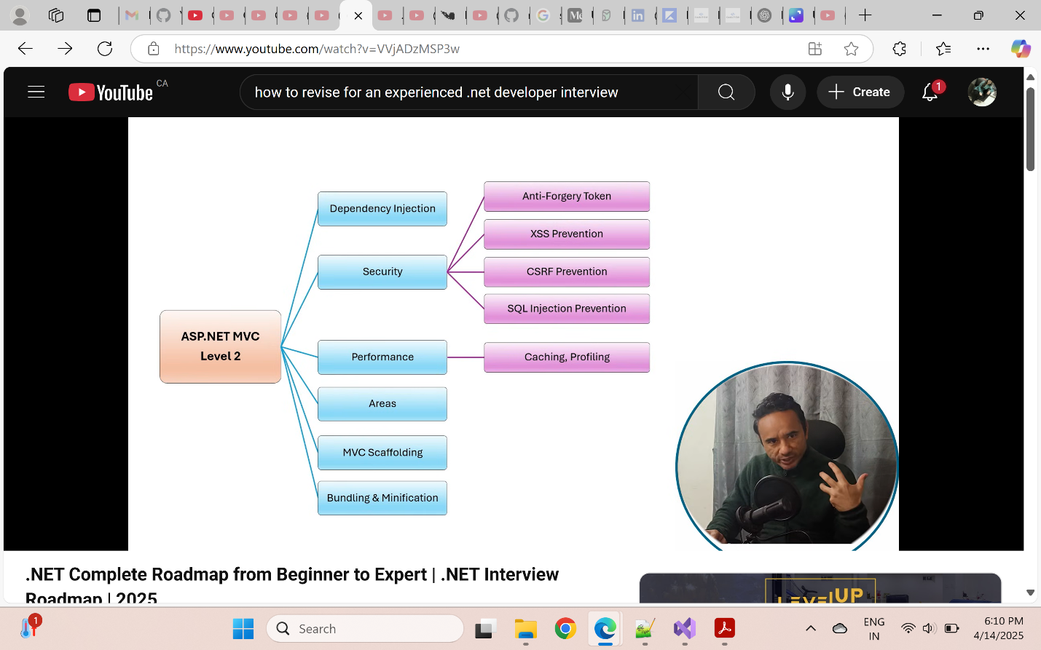

## Asp.net Webforms

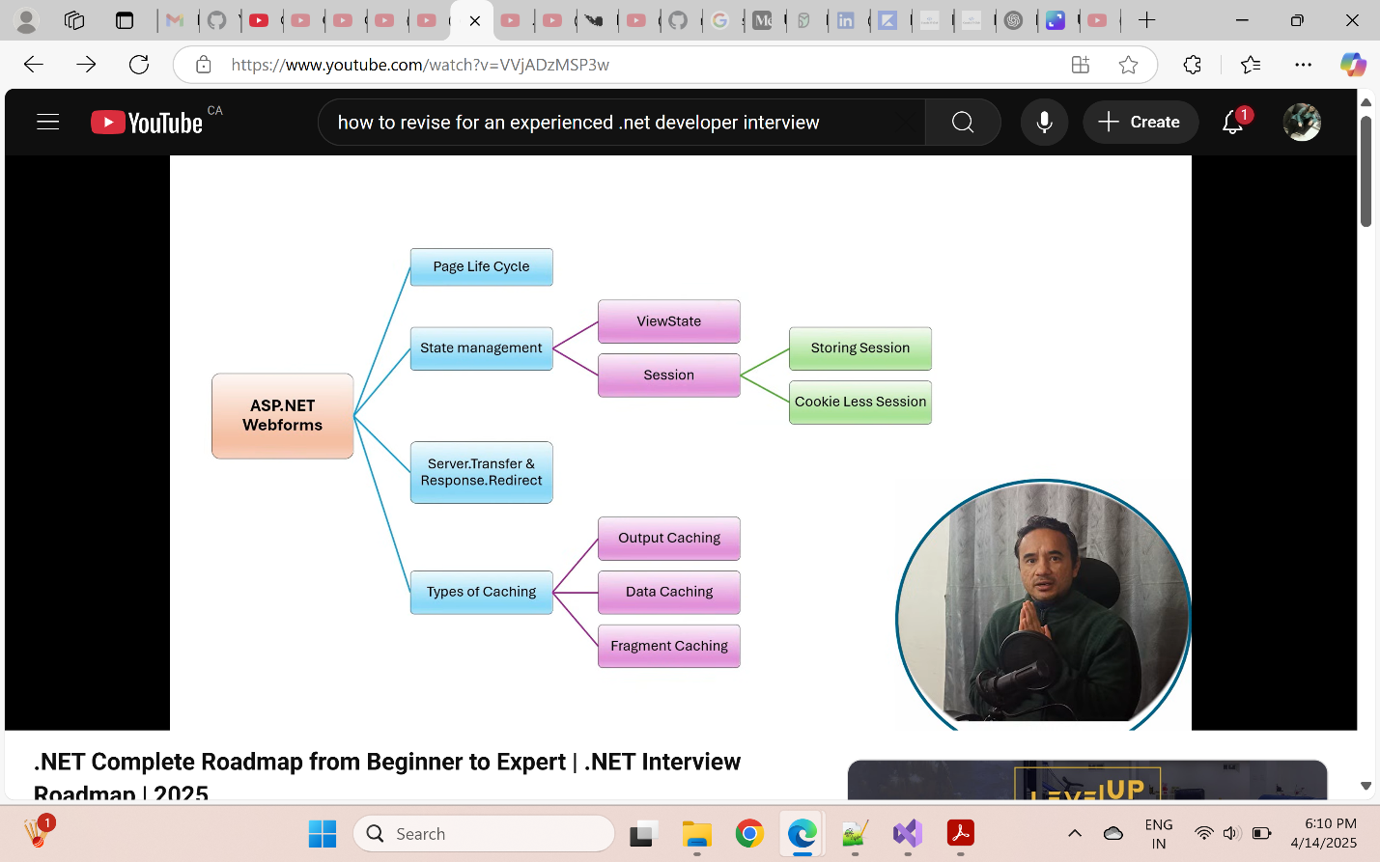

## . ADO.NET/EF

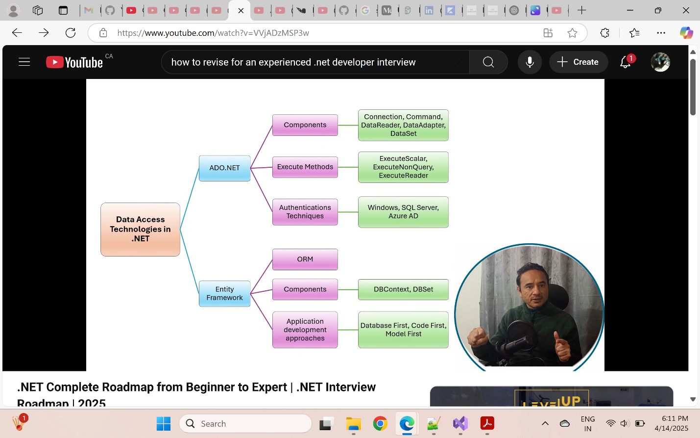

## .Net Core

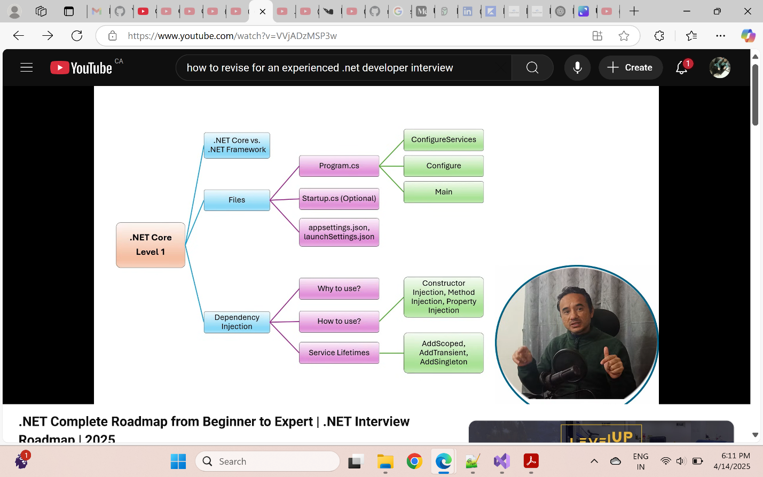

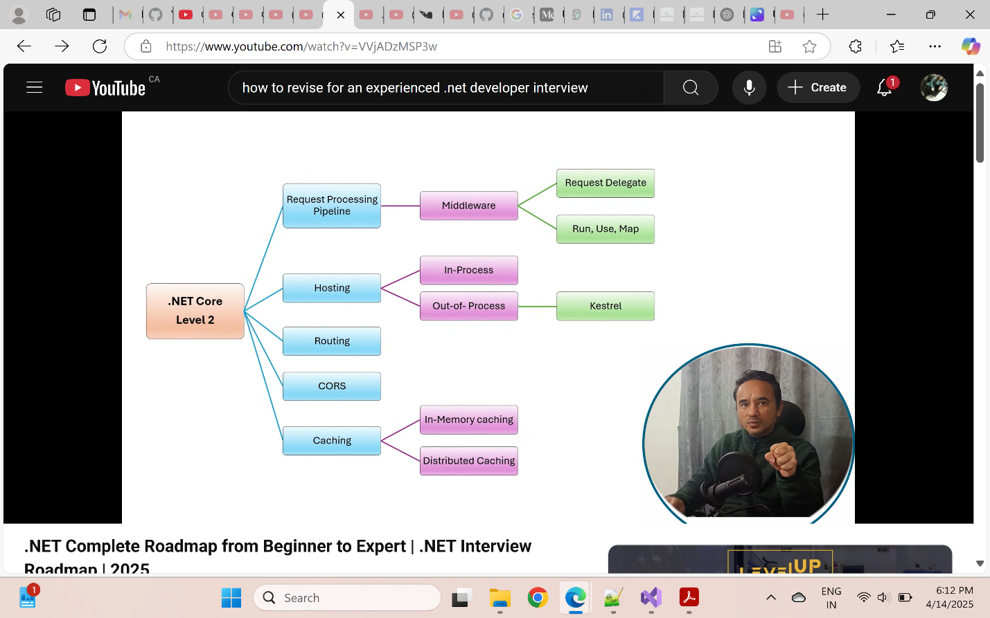

## WebApi

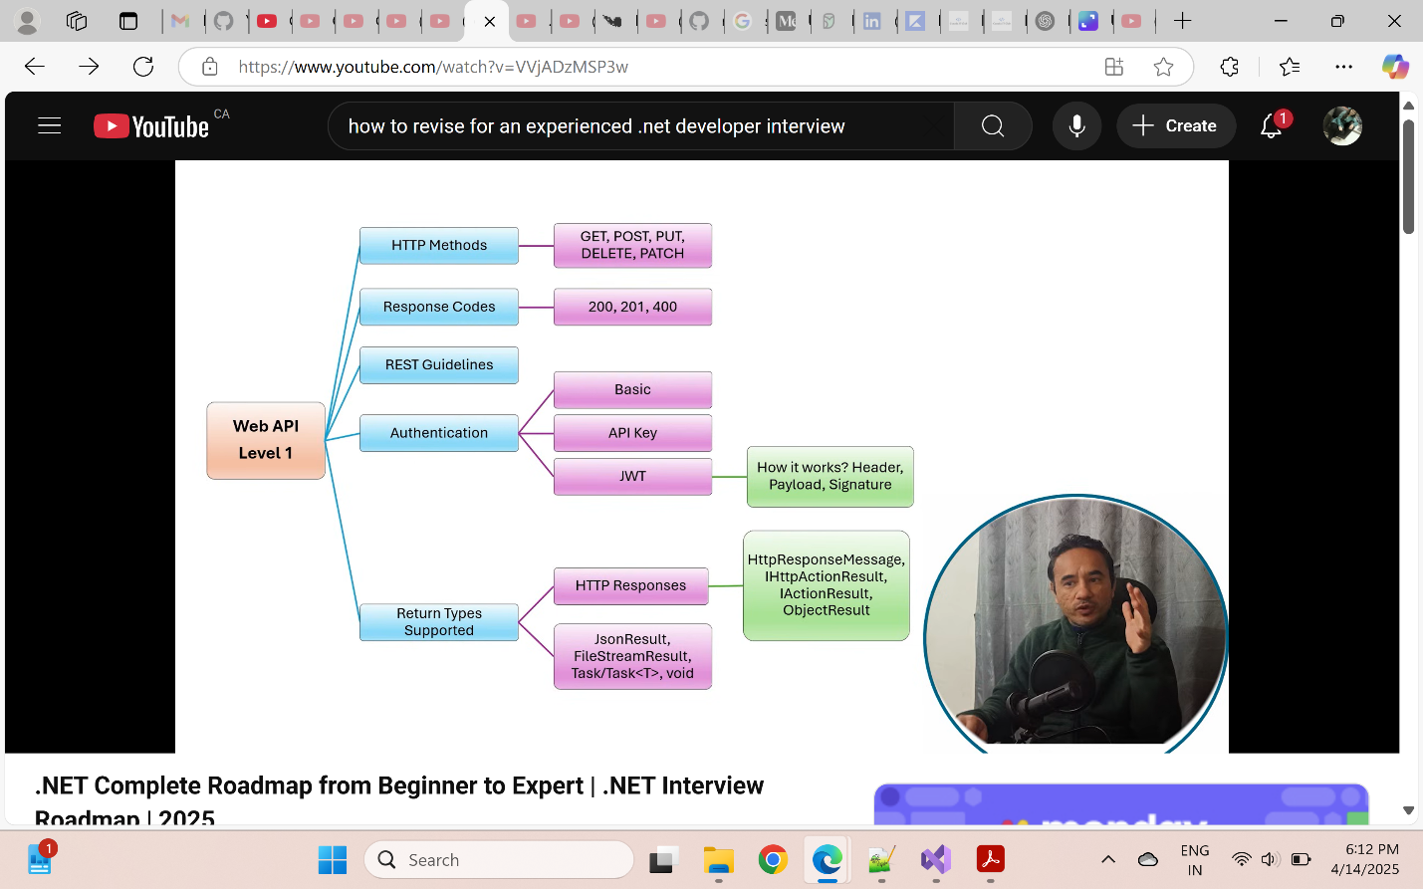

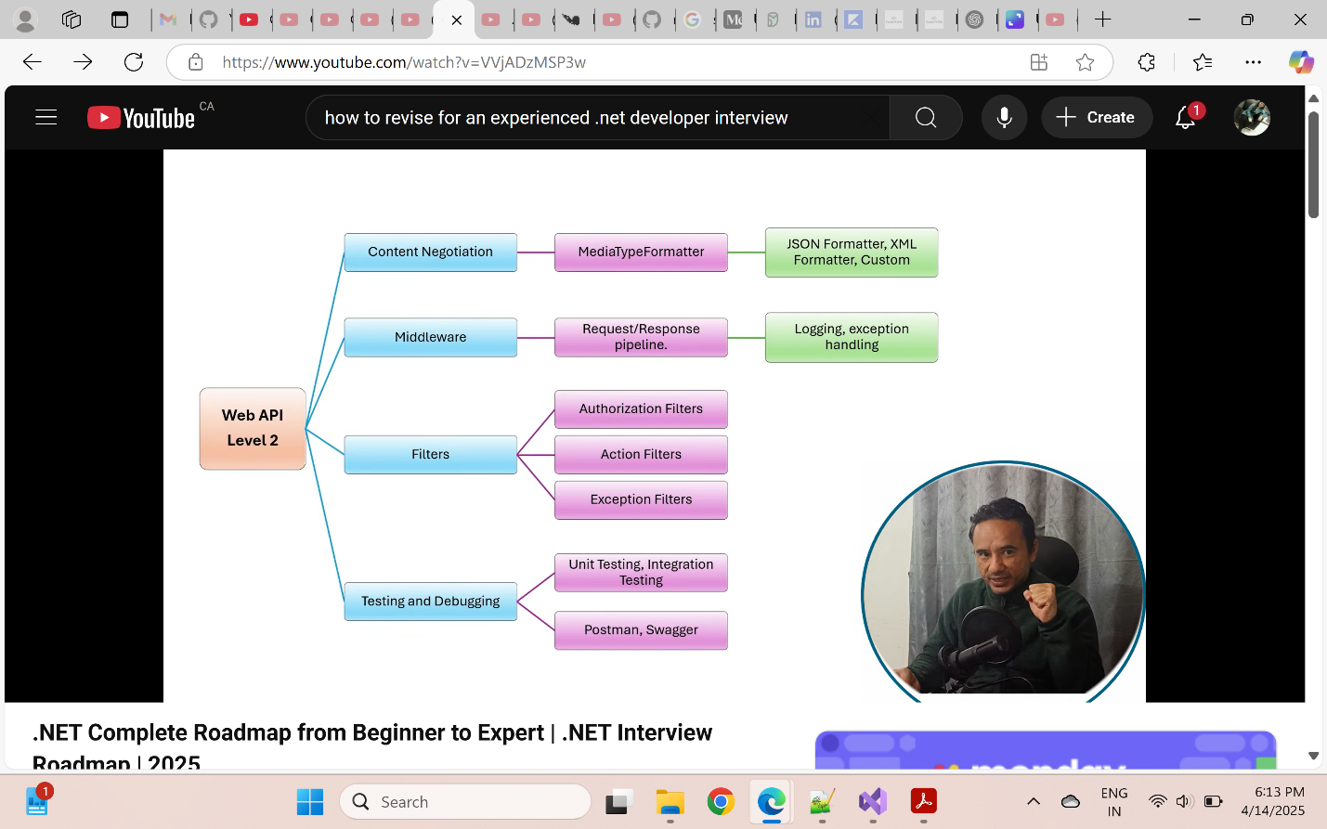

## .Net Advance

